Perform information architecture analysis and design a web service. Research, evaluate and compare web frameworks. Implement the selected framework and emerging technology into the web service. Test and assess the implementation.

WEB701 Report

Web Technologies

13/11/2024

Jayden Houghton – 13524050

Contents

Design (Milestone 1) 2

Project Brief 2

Requirement Analysis 3

Site Goals 3

Mission 3

Goals 3

Intended Audiences 3

Visiting Reasons 3

User Experience 3

Audience 4

Scenarios 4

Competitive Analysis 5

Site Content 12

Site Structure 13

Metaphors 13

Site Organisation 14

Visual Design 17

User Stories 32

Project Management 32

User Stories and Requirements 32

Backlog 33

CRUD Analysis 35

API Prototype 36

Evaluation (Milestone 2) 39

Development (Milestone 3) 39

Conclusion 39

References 39

# Design (Milestone 1)

## Project Brief

The Tech Reconnect charity is a technology supply charity in the Nelson region who offer refurbished and second-hand technology (phones, computers, tablets, chargers, headphones, etc.) to the local community. This provides many benefits, including helping those in need to stay connected with friends and family, and providing devices for children to use in schools.

A website is required for the Nelson region for members of the community to be able to donate devices and for members of the charity to manage and distribute the tech to those in need.

The purpose of the new website is to help with the distribution of the service or product by members of the charity to customers. Like a “food bank”, the website lets members register and describe the service or products they are providing, the number and frequency of the offerings.

The website lets members of the community (beneficiaries) access the service, by providing tokens that can be “spent” to gain technology devices and equipment. To achieve the charity’s goal, the website will have an online token function on the website that lets a beneficiary access a limited number of tokens, for example the system needs a mechanism that verifies that a member of the community is accessing the service and that the token belongs to a particular community member. The website needs some homepage text about general information about the technology offered, how it works and who can sign up.

The following features are required on the website:

1. Charity members and beneficiaries can register, log in and administer their own accounts. Members use the website to register their products and services, and beneficiaries use the system to acquire tokens.
2. Interactive element(s) that engages the website user.
3. The system provides an interface that the members can use to accept a token in a transaction.

## Requirement Analysis

### Site Goals

#### Mission

The purpose of this webapp is to provide a place where those in need can acquire technology to improve their wellbeing, education, and community connectedness. The app will allow anyone in need from the Nelson/Tasman region to register and receive tokens, which can be traded for technology of their need (phones, headphones, computers, chargers, modems, etc.). The goal of this service is to help give everyone the opportunity to education, upskilling, communication, and connectivity to friends and family.

#### Goals

Short-term: give access to technology for education and learning to children in poverty as well as devices to connect friends and families living apart.

Long-term: a more educated, connected and capable community.

#### Intended Audiences

The intended audience of this webapp are people living in the Nelson/Tasman region in a poverty situation, who cannot afford to obtain fundamental technology.

#### Visiting Reasons

1. As someone in need looking for services to assist them
2. As a benefactor of the charity to collect tokens and make a purchase
3. As a donator to donate equipment or other support

### User Experience

The webapp should be simple and intuitive to use on any device, making it accessible to anyone in need.

#### Audience

1. Children from a family living in poverty:
   1. Require computers for school
   2. Phones for communicating with parents and friends
2. Adults living in poverty:
   1. Phones for communication with friends, family and relatives
   2. Device for important emails and banking (rent, bills)
   3. Device for online upskilling or tertiary education
   4. Wi-Fi access and modem for internet at home
3. Donators
   1. Donate devices and equipment
4. Charity members (admins)
   1. Manage members
   2. Upload and manage items

#### Scenarios

**Sue Wilson** – *age* *32, female, 2 kids, no partner, restaurant waiter*

Sue works as many shifts as she can and receives a benefit to cover her expenses and look after her kids, but she barely earns enough to get by. Her brother lives in Palmerston North and was recently diagnosed with cancer. Since her last phone broke, she can only communicate with her family and check emails by visiting the library which has public Wi-Fi. She lives pay check to pay check, so purchasing a phone would take a big cut out of the money she needs to support her family. She wants to be able to communicate with her family quickly and easily so she can stay updated and be able to support them. Through Tech Reconnect, she has been able to acquire a new phone, allowing her to communicate and video call frequently with her family, helping them stay connected.

Persona: adults living in poverty requiring a hone for communicating with family.

**Elias Walker** – *age 13, male, student*

Elias studies at Nelson College and is in year 10. He has a passion for coding and IT. He had been using his mum’s old laptop for his schoolwork, however it was 10 years old and recently stopped working. His family don’t earn enough to be able to afford a new laptop, so he has had to use school computers in the library to do any homework as he no longer has access to a computer at home. This puts huge limitations on him being able to learn and explore his passion of coding. His family signed up to Tech Reconnect and used their combined tokens to purchase a new laptop for him. He has been excelling in his schoolwork and now spends most of his spare time building programmes and developing his coding skills.

Persona: child in an impoverished family requiring a computer for school and passions.

**Steve Anderson** – *age 27, male, unemployed*

Steve has a physical disability which has made it hard to find a job. He has had a few jobs over the last few years, but they are low paying jobs and haven’t lasted long. He has been registered with Tech Reconnect for a few years now, and has purchased items using the token system in the past. He uses his phone frequently to apply for jobs and keep up with current job applications. His phone charger stopped working, cutting off the important ability to job hunt via his phone. Using Tech Reconnect, he purchased a new phone charger which has allowed him to continue his job hunt and recently successfully start his new job as an administrative assistant at a local business.

Persona: unemployed young adult with a physical disability.

#### Competitive Analysis

**Recycle A Device (RAD)**

RAD is a New Zealand initiative that refurbishes and redistributes technology to those in need, aiming to bridge the digital divide for students, families and communities by donating technology to who may otherwise not be able to afford it. In the process, youth are also taught how to refurbish technology (Recycle A Device, n.d.).

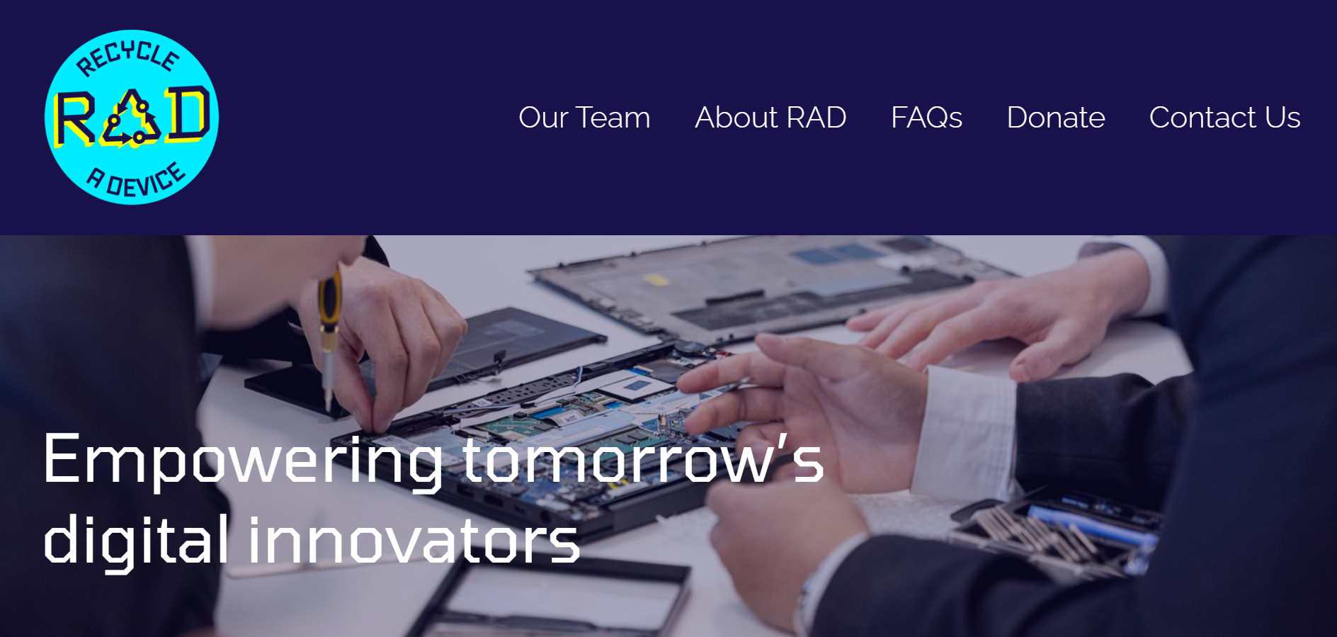

RAD has a clean and simple homepage which allows for easy navigation. The navbar proportions are off (too large), but otherwise it is a good design. This allows for quick and simple navigation across the website. Their homepage includes a number of relevant photos and videos of the charity, as well as text explaining their mission and the benefits offered. This makes it clear and visually interesting to understand what they are and how they operate. The homepage also includes links to easily find key information on the website, including donation links. This helps to direct users to these pages and makes navigation easier.

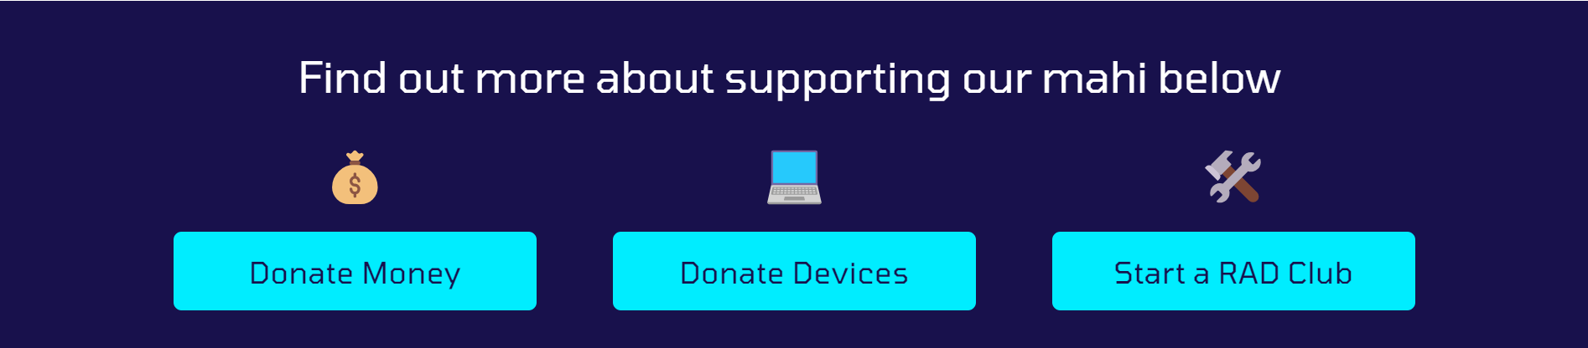

They have also included separate pages for donating money or devices. For devices, a built-in form collects contact data and details, however for money, an external form is used to handle payment. This would have been done to handle transferring money in an easier and more secure way. As our charity can accept devices or money, it would be beneficial to use a similar setup. They also have a contact form with other methods of contact.

The rest of their website is laid out in a similar fashion: clear, simpler, modern and easy to use. This means that anyone coming to the website can easily find what they want and are more likely to interact with the charity by donating or using the service.

The only significant area missing is how to become a beneficiary of the charity. With a cursory glance of the website, there is no information on how to receive one of their refurbished laptops. While they do distribute devices through partnered schools and community organisations, the website would benefit from making this clearer. Overall, this is a very good demonstration of a charity website.

**RE:MOBILE**

RE:MOBILE is a New Zealand non-profit mobile phone refurbishing and recycling scheme accredited by the Ministry for the Environment. Refurbished phones are sold to business specialising in the re-sale of second-hand phones in overseas markets. Over 95% of the materials in recycled phones are recovered (RE:MOBILE, n.d.)

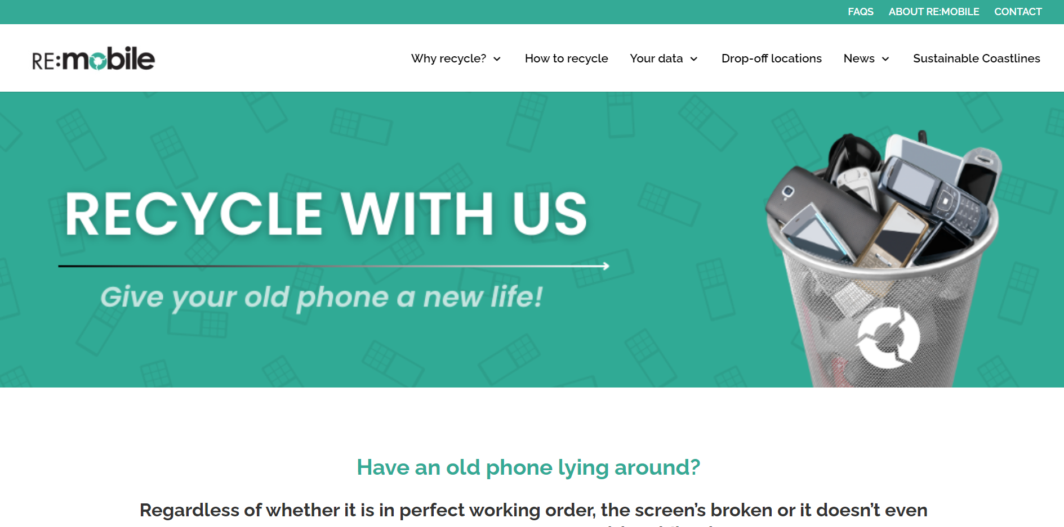

RE:MOBILE also has a simple, clear design which helps for easily navigation.

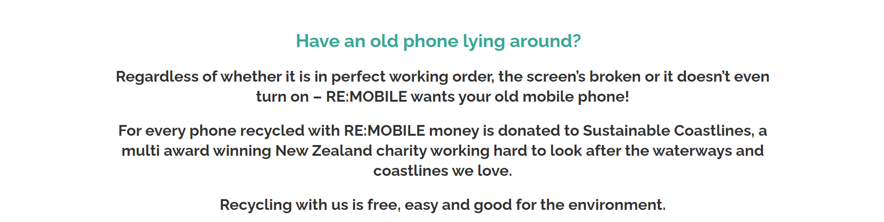

The website states the charity’s mission and purpose with a call to action. This makes the scheme’s purpose immediately obvious to users and motivates them to use it. The website is full of information and statistics explaining the benefits of recycling and refurbishing phones, as well as how the process works.

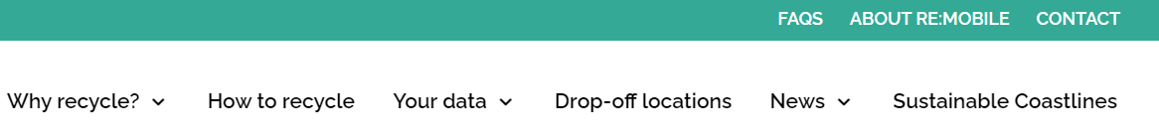

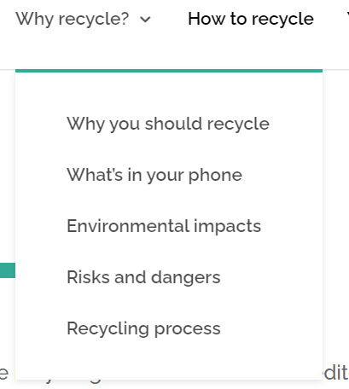I personally think that the double nav bar is confusing and unnecessary.

I also think that there is too much information for the average user, and it is spread out across too many pages. While it is definitely beneficial to include statistics and explanations of the benefits, the average user will likely not read most of this information. By condensing the key points into fewer pages, more users would spend the time to learn and understand the benefits. It would also make navigation to the specific information the user wants a lot easier, improving the usability of the website. Our website will be a lot less focussed on the environmental impacts and risks, so there will be a lot less information to display, meaning this shouldn’t be an issue.

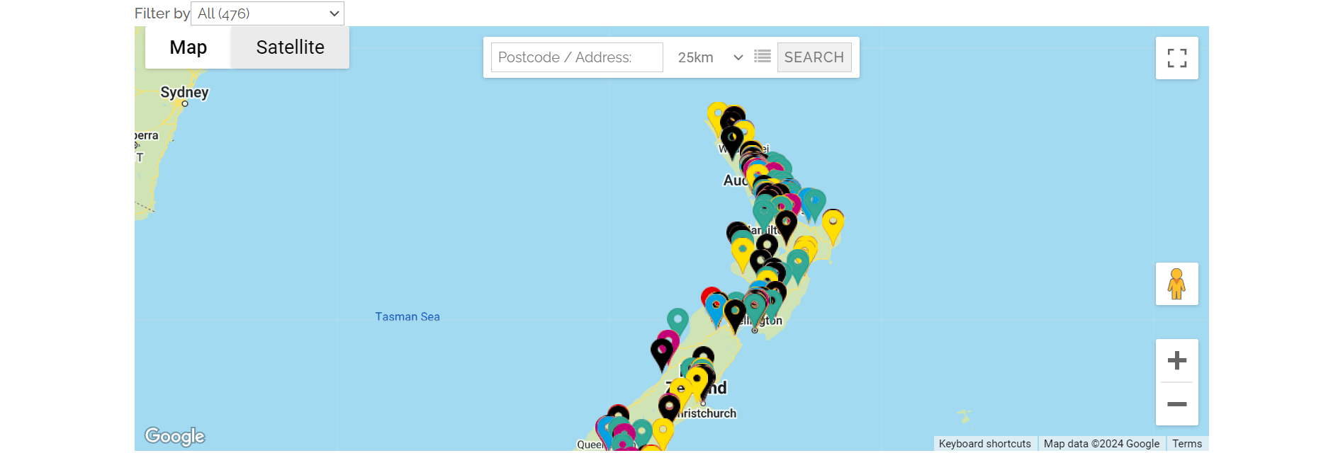

Their website also includes a map with search and filter functionality. As they have many drop of locations, this is a very useful feature for users to work out where to go. This likely won’t be useful for our charity as they are just based in Nelson, unless they expand significantly, however a simple map would be useful.

**TechCharities**

TechCharities is a United States non-profit organisation that refurbishes computers and distributes them to families and students in need. Their goal is to improve quality of life for those in-need (TechCharities, n.d.).

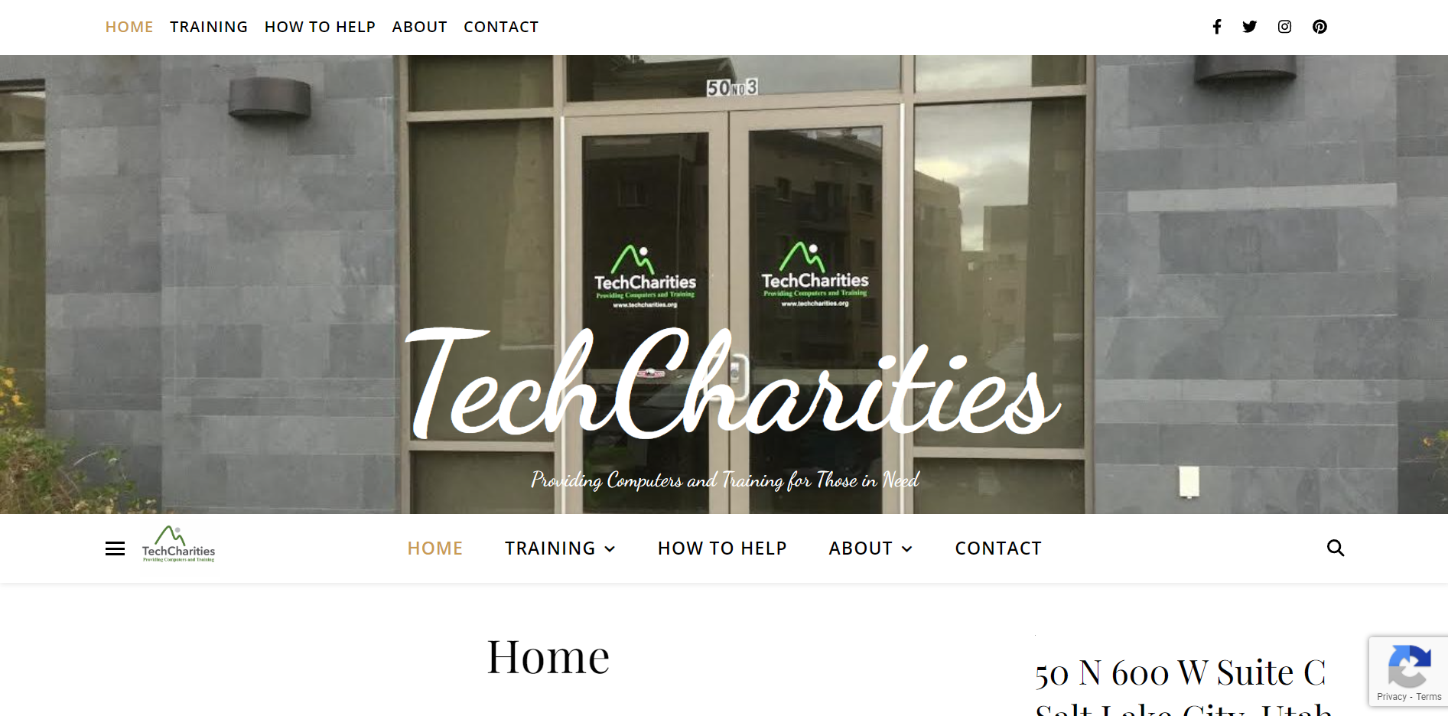

Like the other websites, they have a fairly simple and clean design that improves navigation and usability. The sticky nav bar is a useful addition, however the double it shows at the top of the page may be confusing for some users. Otherwise, the nav provides clear links to key pages on the website.

The mission and purpose are fairly clearly stated at the start of the home page, however the donation and beneficiary links are pushed down the page by the layout. These should be higher up the page to be easier to find.

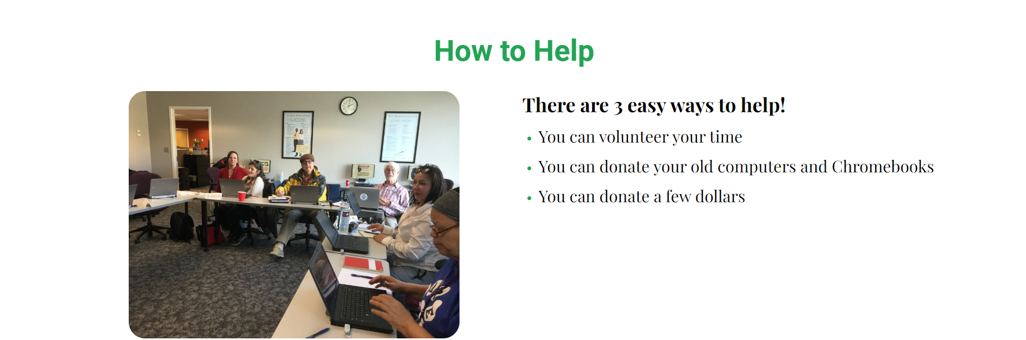

Their how to help section is very clear, making it as simple as possible for donators to help, likely increasing the amount of support they receive. The use of photos builds credibility and builds an emotional connection, motivating users to become involved with the charity. To get to a download think however, users must navigate from the homepage to the ‘How to help’ page then to a donation form, which requires more clicks.

Their donation forms and links however are less simple. They use two different forms for device donation, a Venmo link for money donations and a general contact form. Device contact forms include contact details, estimated device quantity, donation frequency, data security options, documentation requests, delivery options and a message. This allows the charity to gather a lot more information than many other charities do. Contact details, quantity and frequency will all be very important details for our forms to collect. Any devices collected by the charity will be reset and all data wiped, so we should not need this section of the form. While the charity may collect some success stories, they will likely not offer reports or testimonials for donating parties like TechCharities does, so this section won’t be necessary either. Both donation forms are identical but for different end use of the donated devices. This seems like an unnecessary duplication and could be solved by adding a single dropdown to pick what cause the devices are for, however this won’t be an issue on our website.

**World Computer Exchange (WCE)**

WCE is an international charity with the goal of reducing the digital divide for youth in developing counties. International volunteers refurbish computers that are donated to schools and community organisations in developing countries. The charity also provides digital training and coding bootcamps (World Computer Exchange, n.d.).

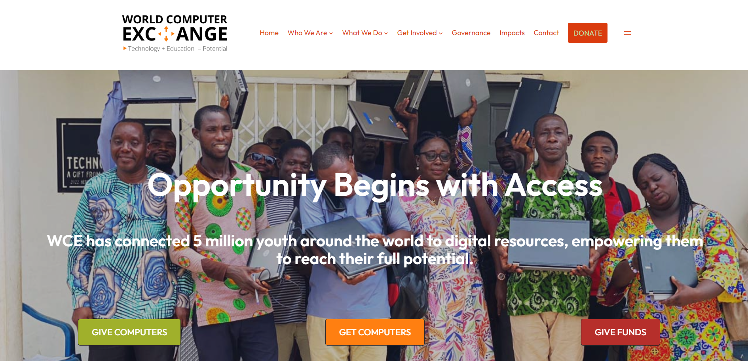

WCE has a very good home page:

* Clear nav bar to navigate to key pages
* Concisely shows their purpose and global benefit already achieved
* Immediately displays links for donors and beneficiaries to direct users
* Donation link in nav bar for easy access and quick navigation
* Lists featured impacts showing other benefits and stories immediately after the top banner
* Lists community support and quotes for credibility
* Home page includes links to other sections of the site (who we are, what we do, etc.) to help the user easily find the information they want

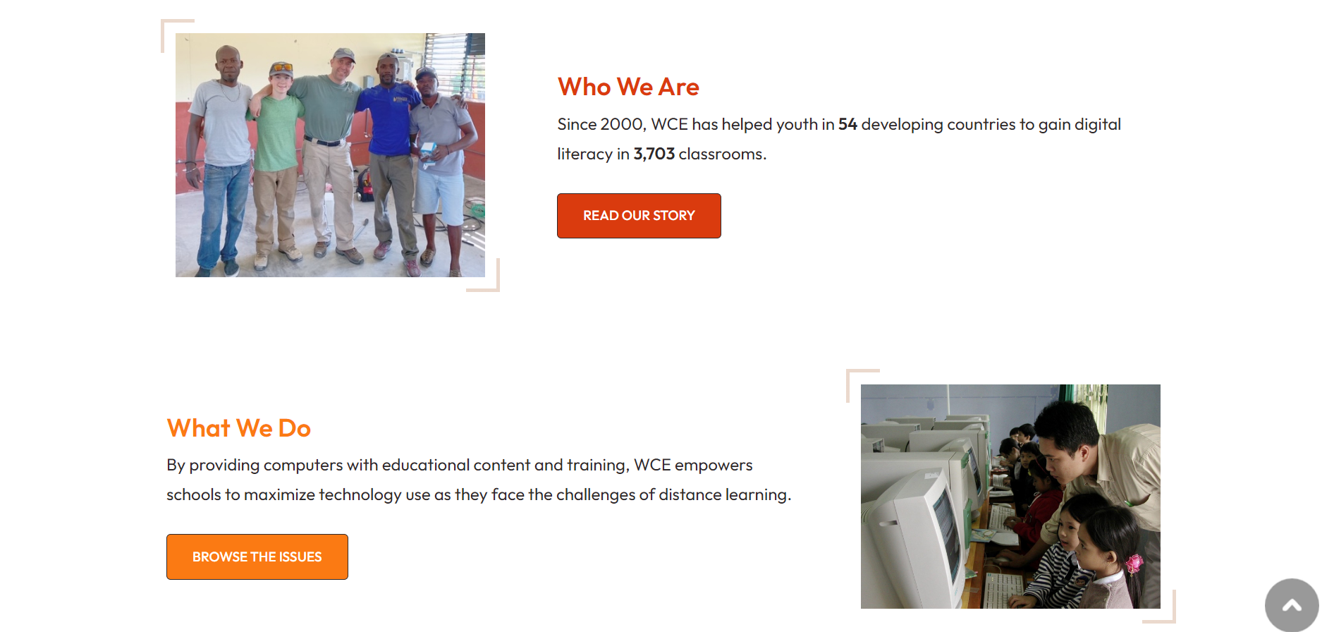



Information is displayed in highly readable and organised methods, improving the usability of the website. The website includes plenty of information about how the charity works, success stories and the benefits they have produced, but doesn’t overload the user with too much text or details. This is a very well designed website. Plenty of links on the homepage help direct users through the website and to the information they want.

WCE offers a large variety of donation methods. For fund donations, they accept PayPal, check or credit card. ReTech will not accept checks but will have some form of online payment. WCE also accepts device donations by drop-off, mail-in or business collection. ReTech will only support drop-off for the safety of the devices and as they only operate locally. Each form requires contact details, donation description and an address.

For requesting computers, WCE does not use a form on the website or a shop system, but downloadable Word document forms.

**Digital Wings**

Digital Wings is a New Zealand charity that provides IT equipment and support to charities and community organisations. Their goal is to support other organisations in promoting digital technologies to those digitally disadvantaged or underserved (Ditgital Wings, n.d.).

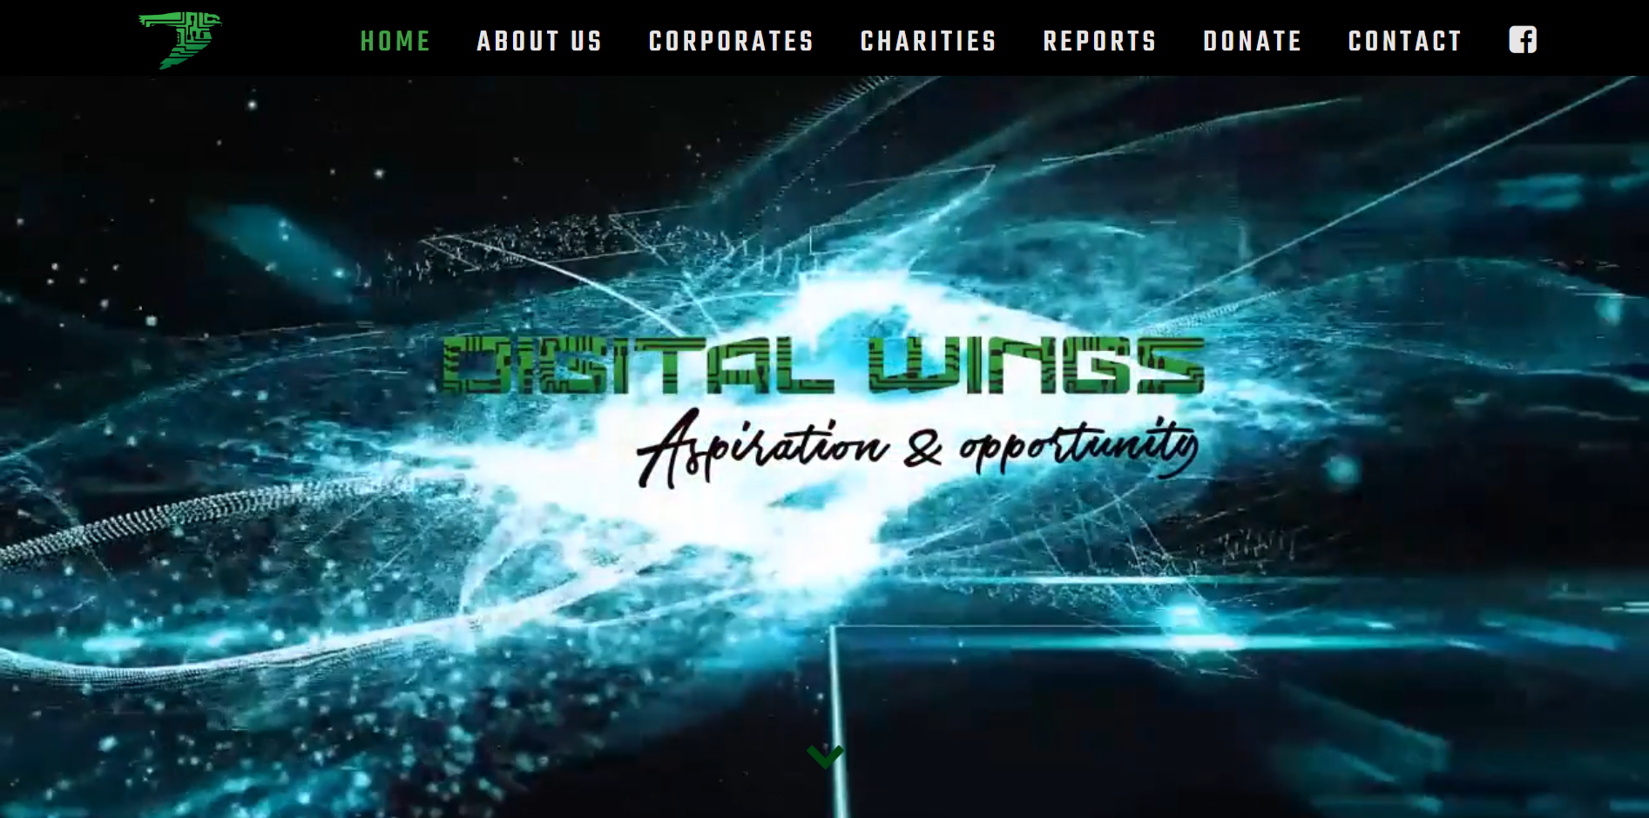

Digital Wings has a looping complex animation on the home screen, which makes it overly busy and overwhelming. The background image combined with font choices makes some sections of the website difficult to read, posing an accessibility concern. They provide statistics on the charity and links to success stories on the homepage, making it easy for users to find these sections. Their purpose and goals are clearly laid out helping user’s understand the charity easily, however the theme of the rest of the website is very different to the homepage.

Information is presented via methods that are more difficult to read and make finding information more difficult, such as the scrolling list of charities. Donation information is limited, which may dissuade some users from donating. The website overall feels busy and slightly disorganised, making it more difficult to use.

Their home page includes links to other pages, which helps direct users to these sections. Digital Wings has implemented a number of slideshows across their website. This is a good way to show more statistics and images such as location maps which the user can interact with. Donations are processed by a partner business, so the donation link takes you to a 3rd party site.

**Summary**

Features of a good charity website:

* Clear nav bar for easy navigation across key pages
* A few images to build credibility, demonstrate the charities work and make the website more visually interesting – sideshows are good for lots of images
* Display statistics of how the charity has helped
* Diagrams and infographics help communicate information quickly and in an interesting format
* Donation and beneficiary links should be near the top of the home page and ideally in nav bar
* Clearly display the charity’s mission and purpose at the top of the home page
* Include information about the charity (who they are, what they do, how it works, etc.) in a concise format
* Clear information on how to donate or receive the charity’s service
* Contact form + contact details (email, social media)
* Use a secure 3rd party service for financial donations
* Multiple options for financial donations means it is easier for users to donate
* Donation form should include contact details, device quantity, frequency, and a message/description
* Built in forms are easier than downloadable documents

### Site Content

**Content**

* Navigation bar between main pages
* Statistics of charity benefits
* Statistics of people in need with technology
* Charity mission/purpose
* Donation link
* Sign up form
* Login form
* Images of charity service
* Success stories with images
* About the charity
* What the charity does
* How the charity works
* Receive tokens
* View tokens
* Account details
* Shop
* Purchase confirmation
* Member list and controls
* Upload items

**Functional Requirements**

* Login to an existing account
* Register new accounts as beneficiary or charity member
* Members can donate items
* Beneficiaries receive tokens on a semi-regular basis (tbc)
* Beneficiaries can purchase items from the shop with their tokens
* Users can update account details
* Users can delete their account
* Responsive design for mobile and PC

**Grouping**

Using the content and functional requirement lists, I worked through the process of grouping related items together to begin forming the website structure of pages. I want the website to be easy to navigate and for content to be laid out in a logical manner, so it is important that content is grouped appropriately. The final list can be found under Site Structure List.

### Site Structure

#### Metaphors

**Organisational**

The about page of the website will reflect the organisational structure of the charity. This page will talk about the Board of Trustees, the different sections of the charity (e.g. management, shop volunteers), partner organisations, and ‘shopfront’ locations.

**Functional**

The shop section of the webapp is modelled and inspired by physical shops. Items are laid out on the screen like they may be in a shop window or on shelves, so users can browse what items are available. Clicking on an item to view more details is like stopping to pick up and item and read the packaging. There will also be a cart system and checkout page, which is a digitalised version of a physical cart to store items and the checkout process when leaving a store.

**Visual**

The theme and design of the website will be inspired by computers. The website will be laid out in a logical and organised fashion like items on a computer (e.g. files in a folder). It will use a sleek and modern theme like new laptop designs, utilising clean, easy-to-read fonts and a simple monochromatic/muted design.

#### Site Organisation

**Site Structure List**

* HOME PAGE
  + Charity mission/purpose
  + Images of charity service
  + Donation link
  + Become a benefactor link
  + Success stories with images
  + Statistics of charity benefits
  + Statistics of people in need with technology
* ABOUT PAGE
  + What the charity does
  + How the charity works
  + Goal/purpose
  + Charity leaders and team
  + Images of charity service
* LOGIN PAGE
  + Login form
  + Link to register form
* REGISTER PAGE
  + Sign up form
  + Link to login form
* CONTACT PAGE
  + Contact form
  + Contact details
  + Social media links
  + Address and map
* BENEFICIARY ACCOUNT PAGE
  + View tokens (automatically receive)
  + Purchase history
  + View items to be collected
  + Account details (includes updating and deleting account)
  + Logout
* SHOP PAGE
  + View items available (item name, token cost, details, quantity)
  + Purchase items
* ITEM PAGES
  + View item’s name, token cost, details, quantity available
  + Add to cart
  + Delete or update (admin/staff only)
* DONATOR ACCOUNT PAGE
  + Account details (includes updating and deleting account)
  + Donation form
  + Logout
* STAFF ACCOUNT PAGE
  + Account details (includes updating and deleting account)
  + Upload items to shop
* ADMIN ACCOUNT PAGE
  + Account details (includes updating and deleting account)
  + Upload items to shop
  + View and manage all account
  + Create new staff/admin account

**Architectural Blueprint**

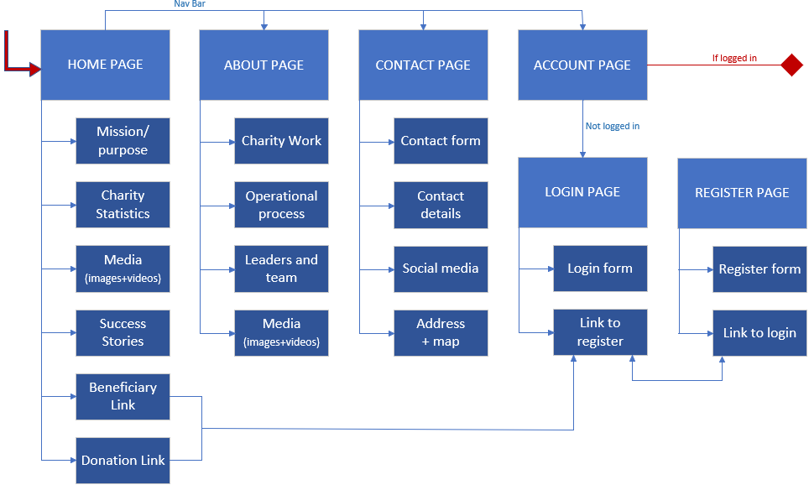

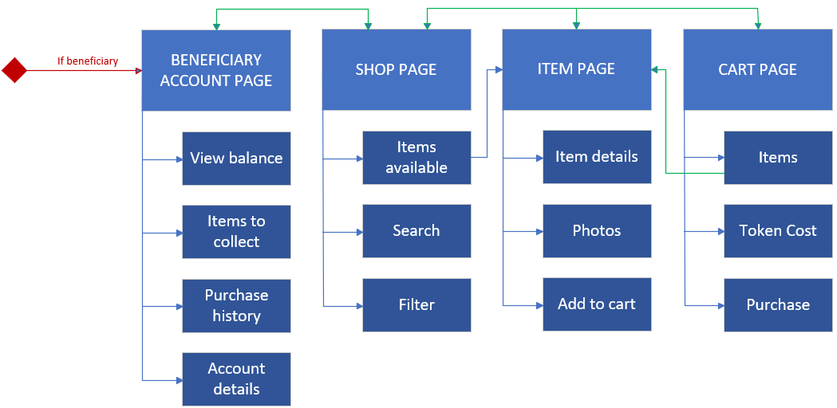

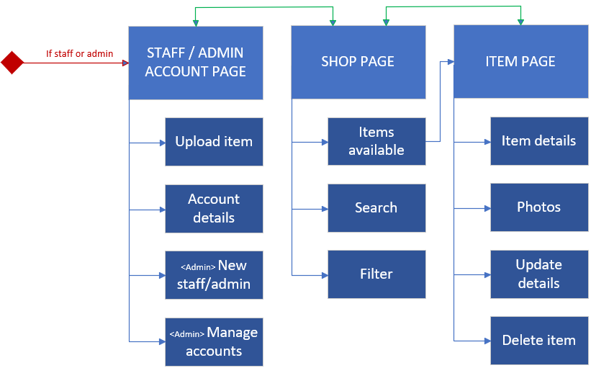

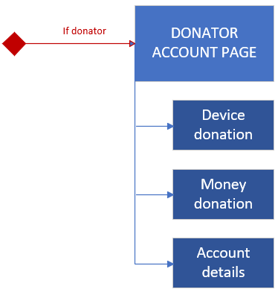

#### Visual Design

**Home Page**

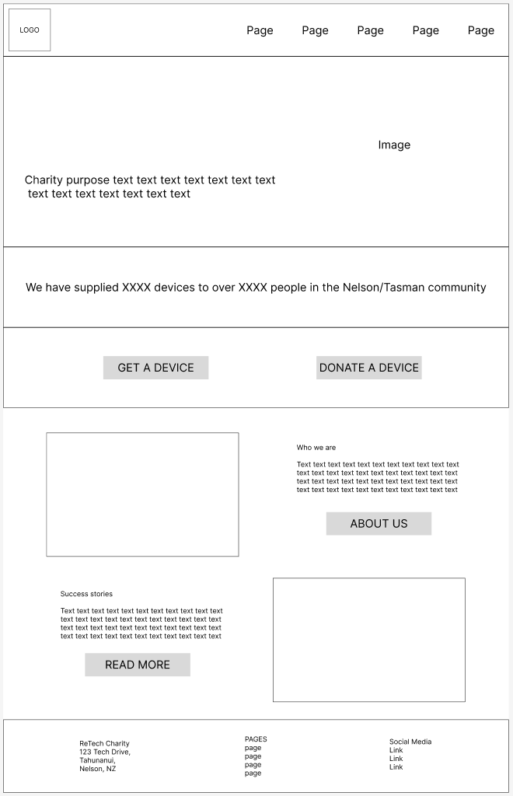

**About Page**

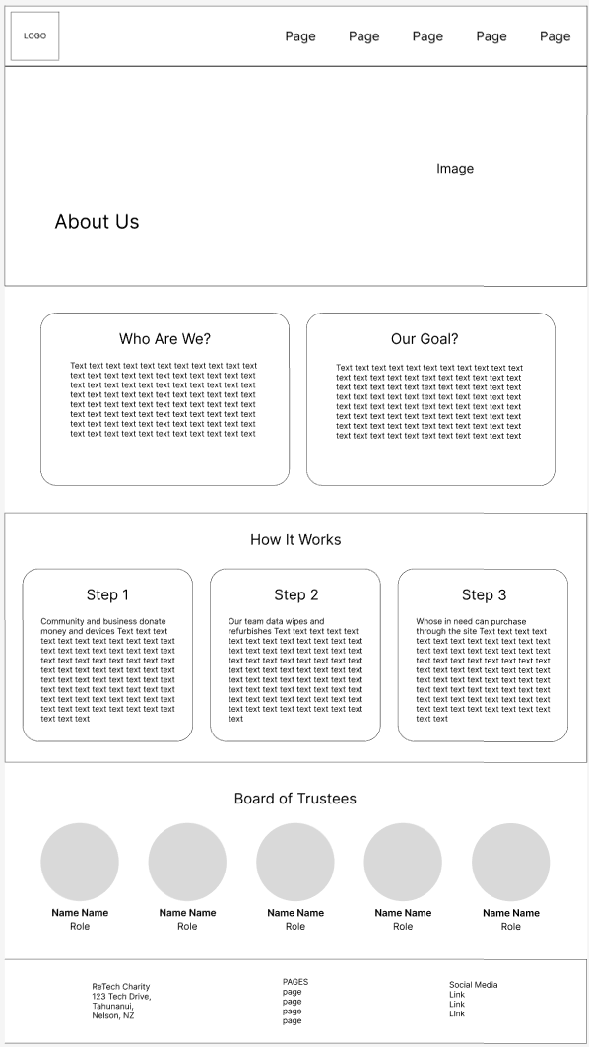

**Contact Page**

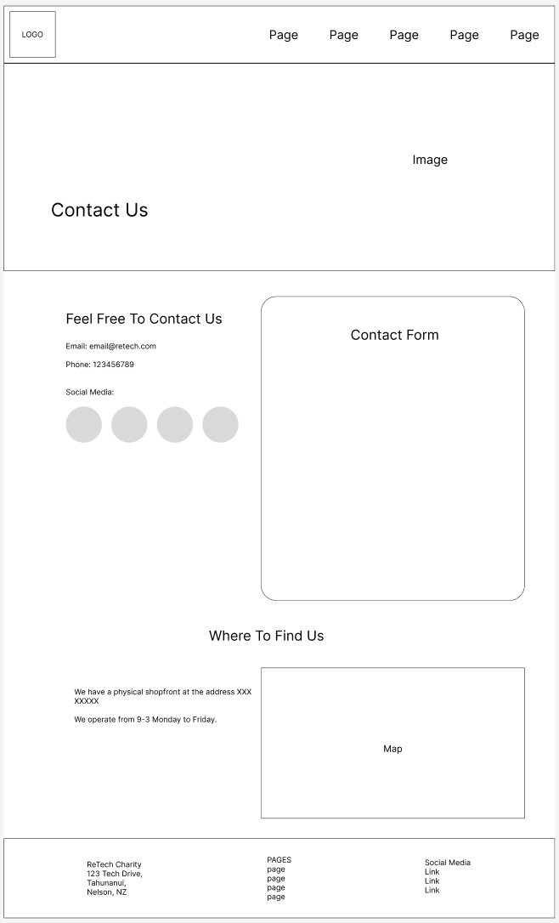

**Login Page**

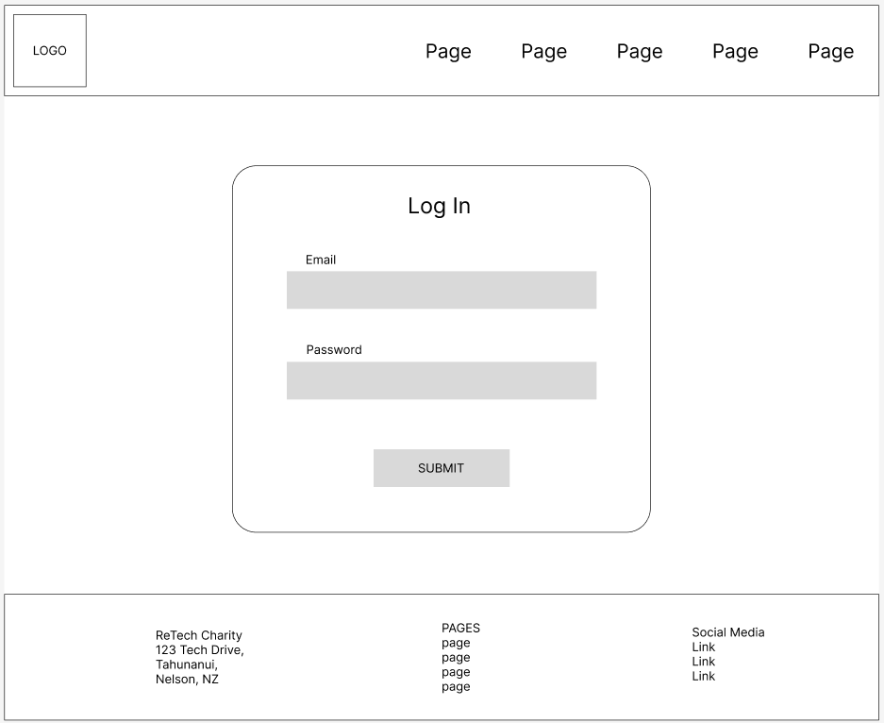

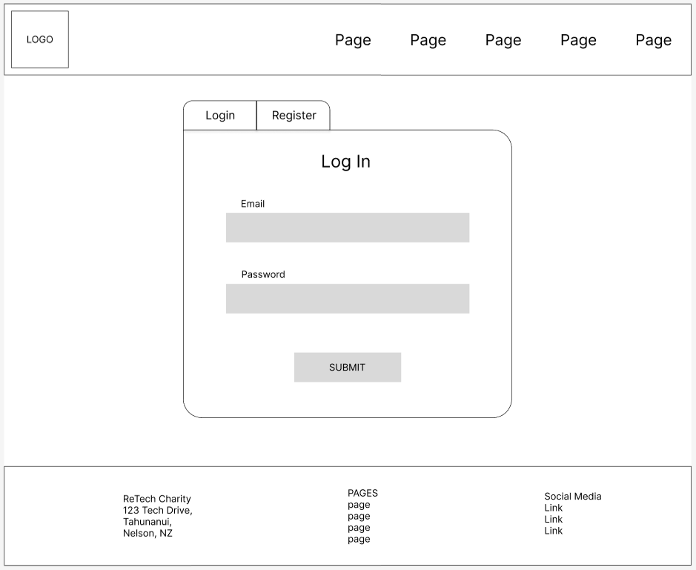

**Register Page**

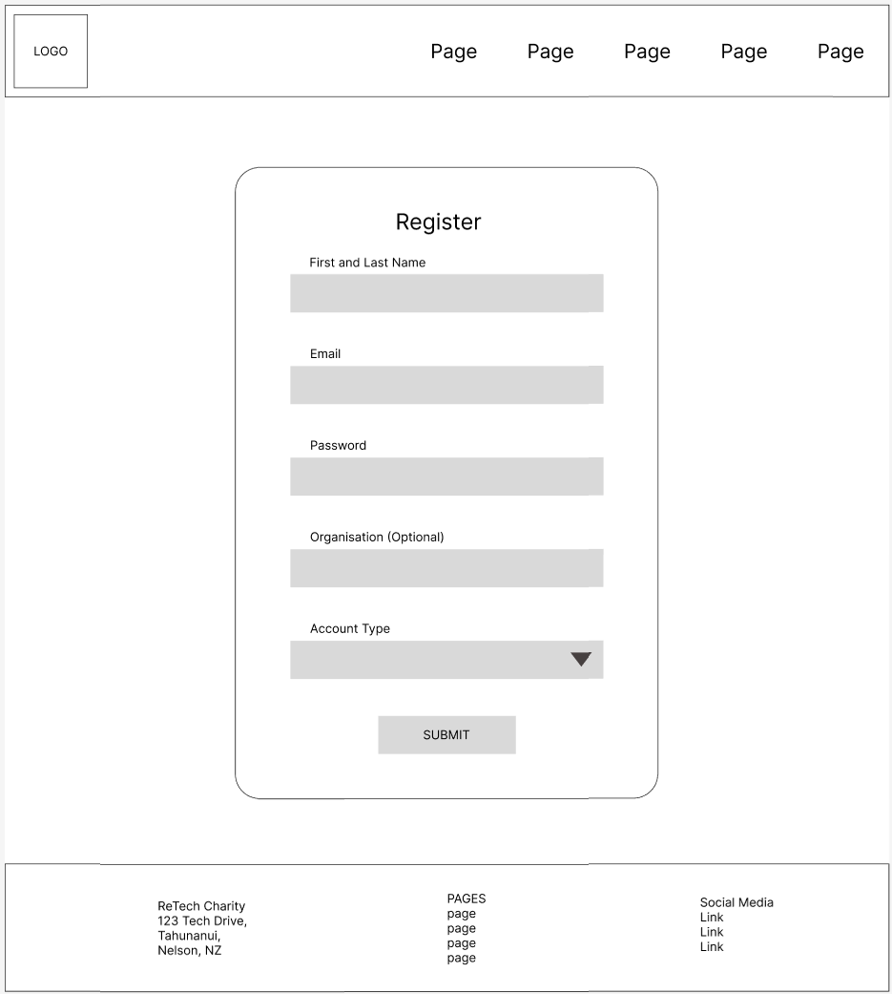

**Donator Account Page**

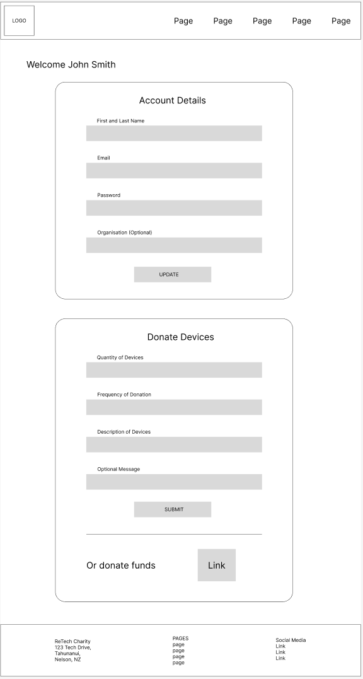

**Beneficiary Account Page**

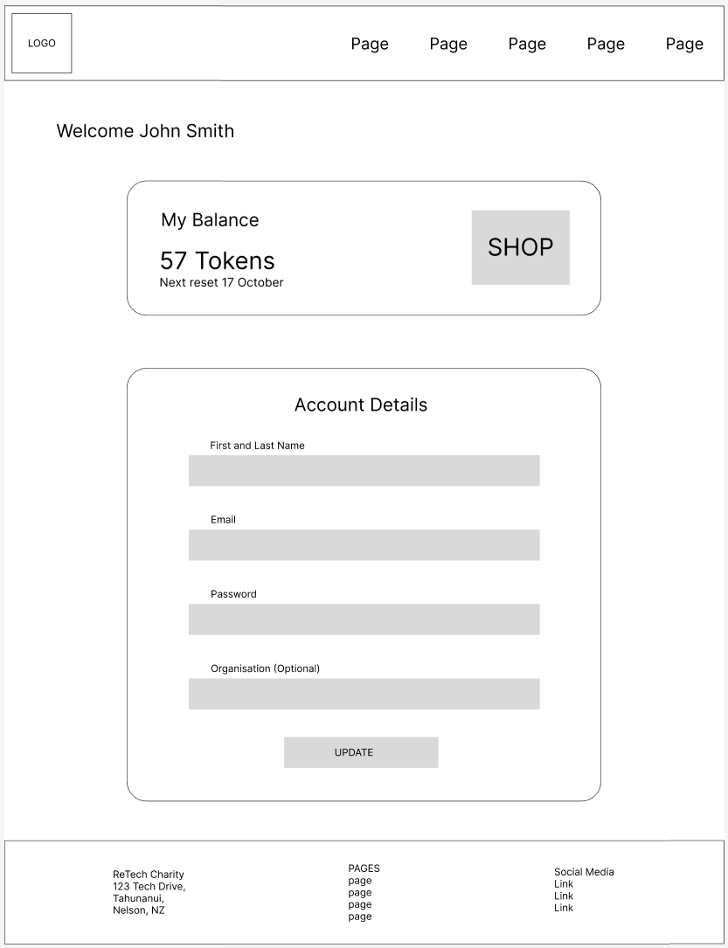

**Shop Page**

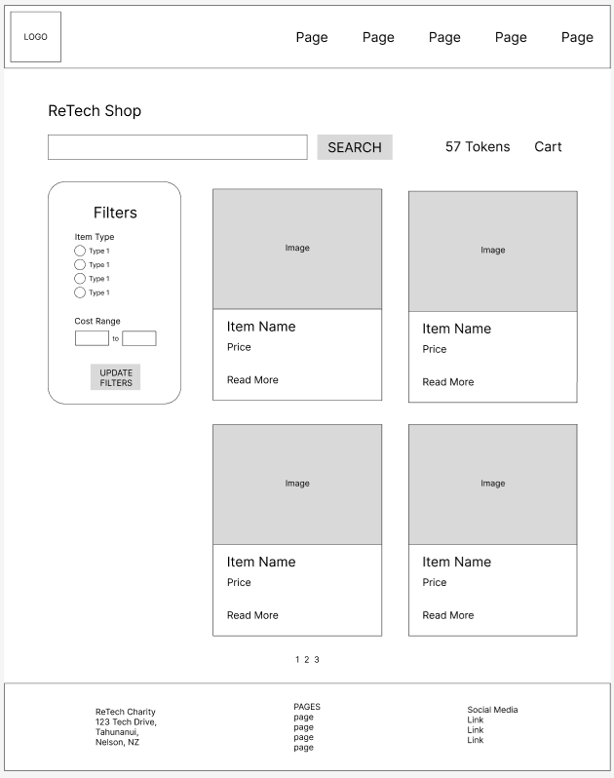

**Item Page**

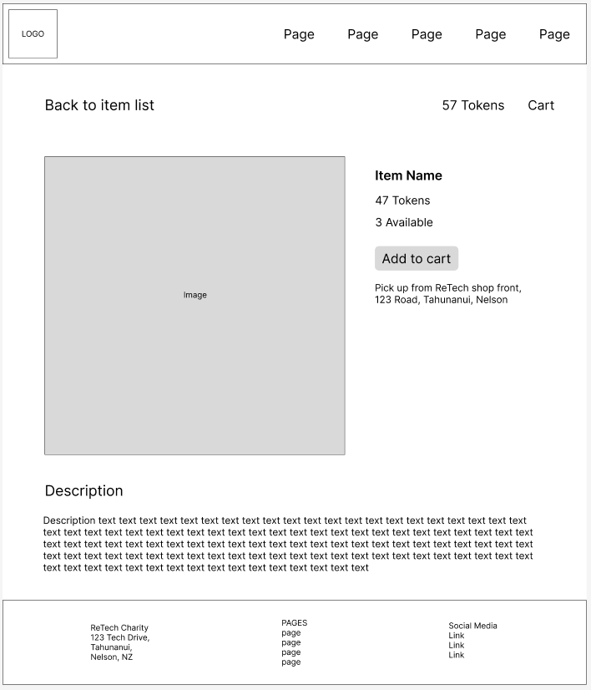

**Cart Page**

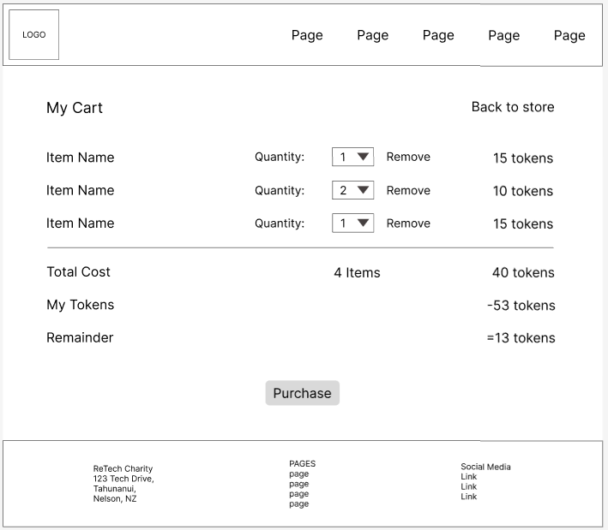

**Staff/Admin Page**

Staff and admin are the same except the accounts option is only for admins.

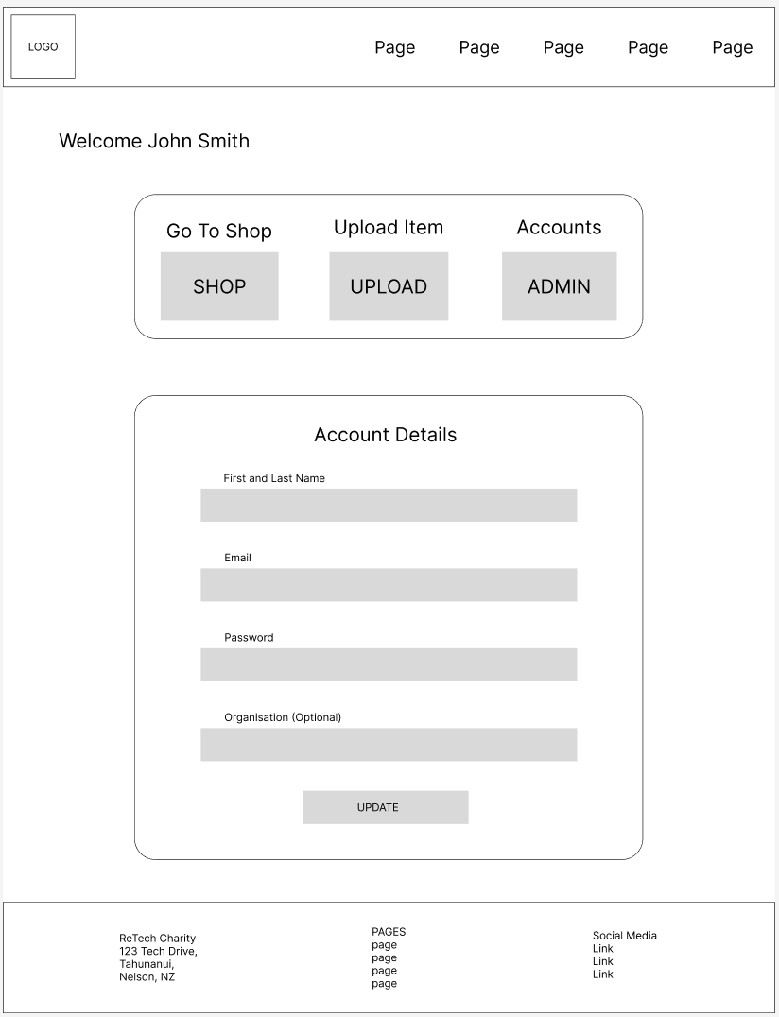

**Upload Item Page**

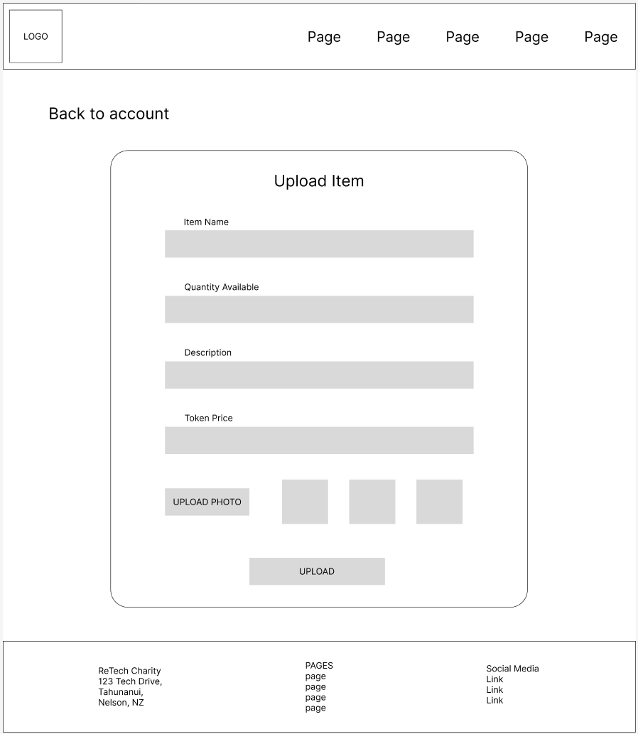

Admin Page

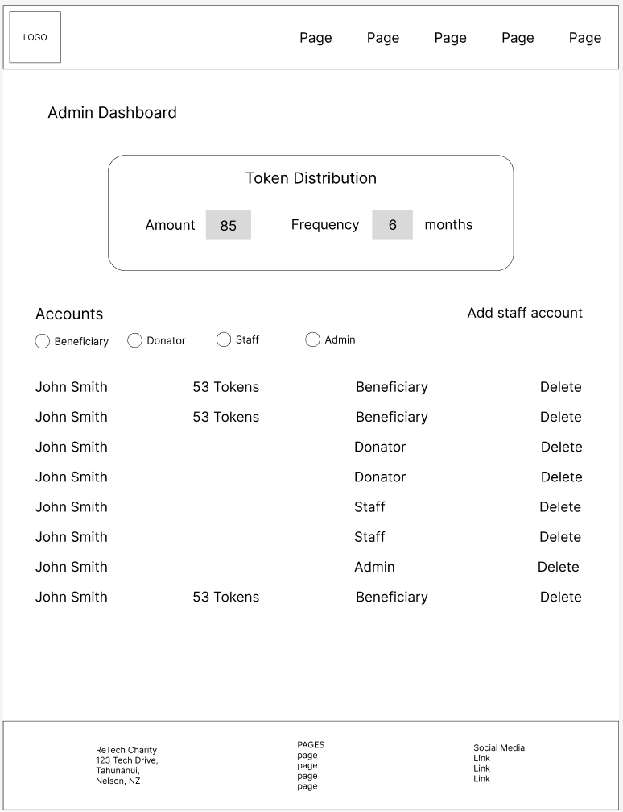

**Colour Mockup**

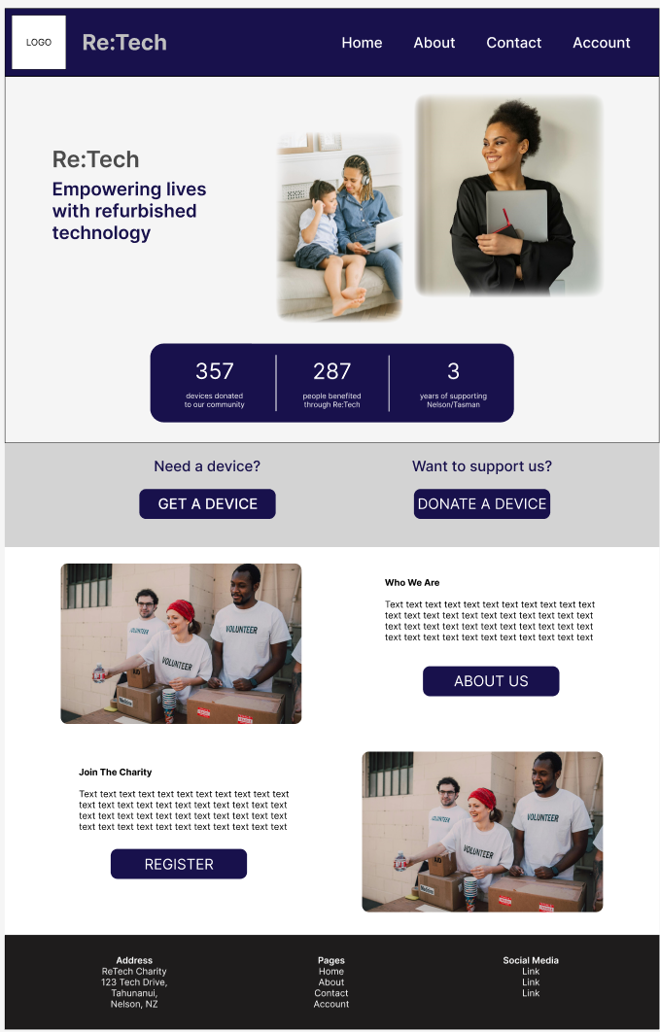

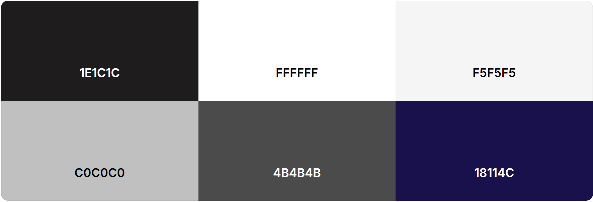

## User Stories

### Project Management

#### User Stories and Requirements

1. As a donator, I want to donate devices to support people in need.
   * Register/login
   * Device donation
2. As a donator, I want to donate money to support people in need.
   * Money donation
3. As a donator, I want to have administration power over my account to be in control of my data.
   * Account page (update data)
   * Delete account
4. As a potential donator, I want to learn about the charity to decide if I want to support it.
   * Home page
   * About page
5. As a potential donator, I want to get in contact with charity staff to get additional questions answered.
   * Contact page (contact form)
   * Social media links
6. As a beneficiary, I want to be able to easily view all available items with their details to be able to find what I need.
   * Search, filters
   * Shop page and item pages
   * Cart + purchase
7. As a beneficiary, I want to be able to view my tokens, so I know how much I have to spend.
   * Account page (tokens view)
8. As a beneficiary, I want to be able to see how I have used my tokens so I can track how I have used the charity’s service.
   * Purchase history
9. As a beneficiary, I want to have administration power over my account to be in control of my data.
   * Account page (update info and delete account)
10. As a beneficiary, I want to pick up the items I have purchased with my tokens to use those devices to improve my situation.
    * Items to collect list (account page)
    * Map and address (contact page)
11. As a potential beneficiary, I want to know how the charity can help me to know if I should register.
    * Home page
    * About page
12. As a staff member, I want to be able to upload new items so there are always items available for beneficiaries to purchase.
    * Upload page
13. As a staff member, I want to be able to manage items on the shop so that the items in the shop reflect the items available.
    * Update item page
    * Delete item
14. As an admin, I want to be able to manage accounts so we can manage and moderate our users.
    * User list
    * Delete account
15. As an admin, I want to be able to create new admin and staff accounts so that we can easily expand our team.
    * Create admin/staff account page
16. As an admin, I want to be able to manage when and how tokens are given to beneficiaries so we can update this to reflect our supplies.
    * Token settings (quantity, renew frequency)

#### Backlog

I have implemented a simple scrum hierarchy in DevOps to represent the different user stories and the features that must be implemented for each.

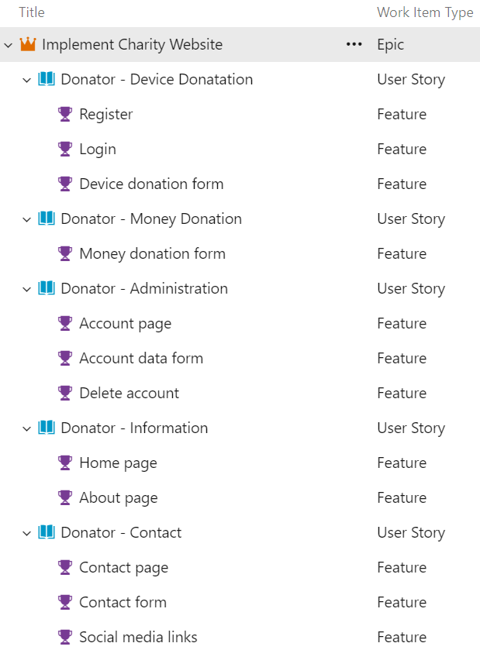





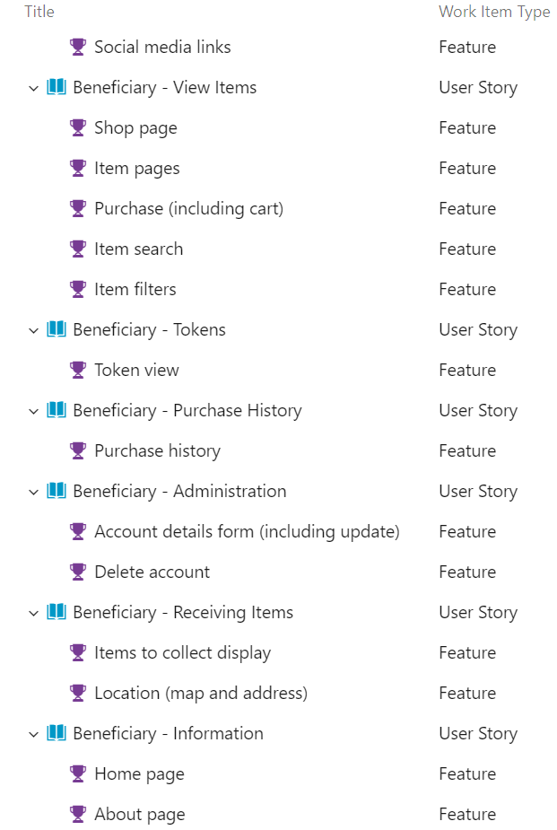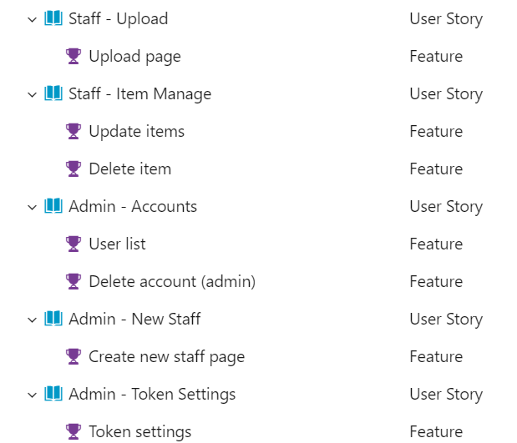

### CRUD Analysis

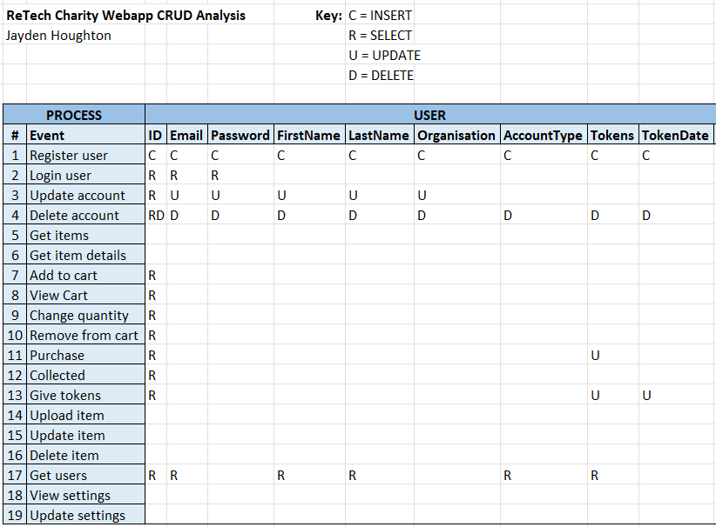

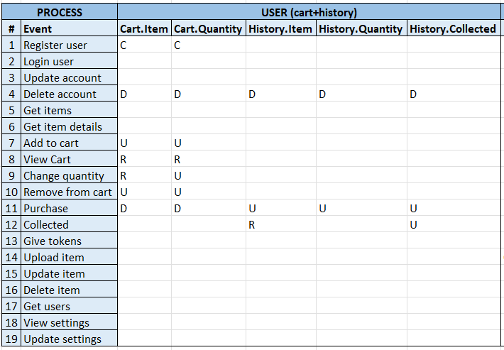

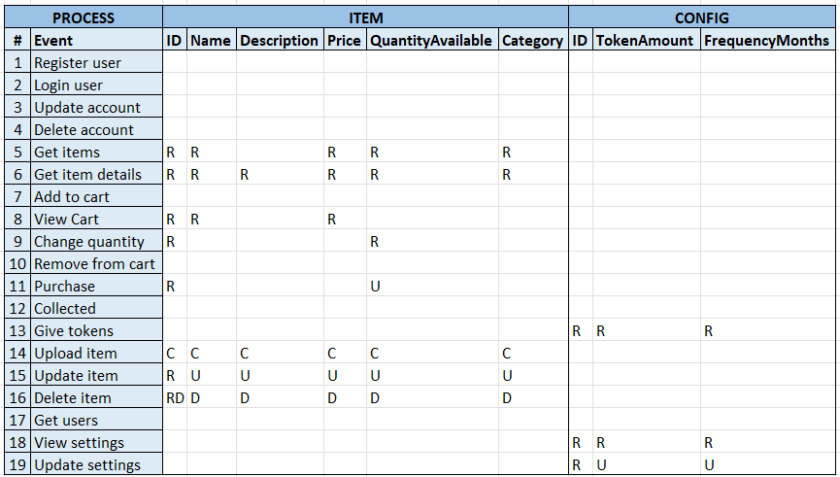

### API Prototype

Project at: <https://github.com/Jayden-Htn/WEB701_Project>

Note: some routes are used to perform multiple operations for different processes (e.g. user update can update user details, cart details, purchase history, and tokens as they are all stored as user details), however these can be split into multiple routes as required during implementation.

**Users Routes**

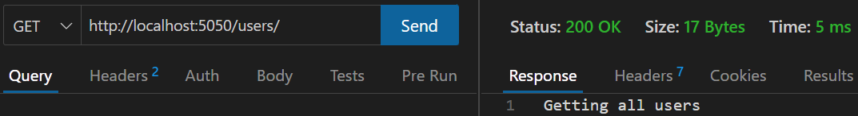

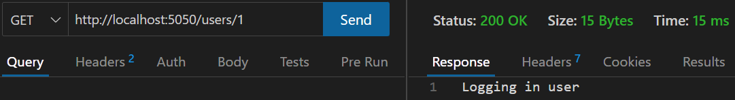

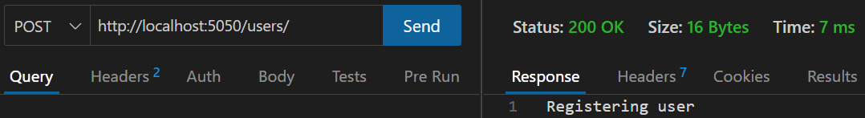

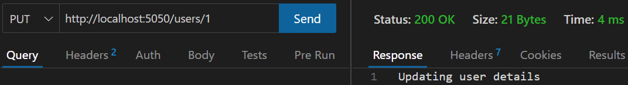

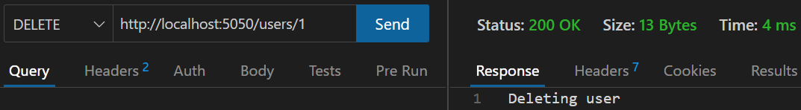

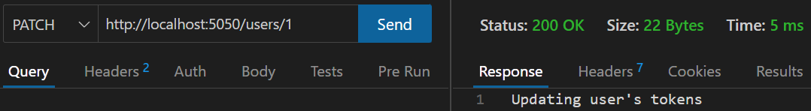

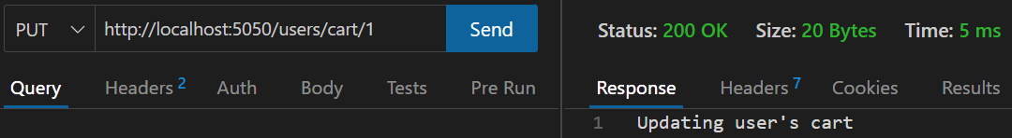

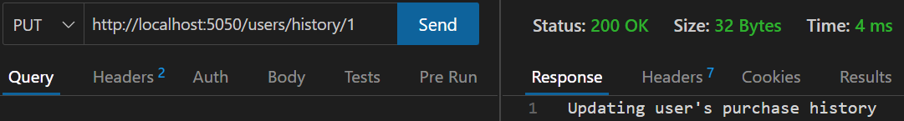

**Items Routes**

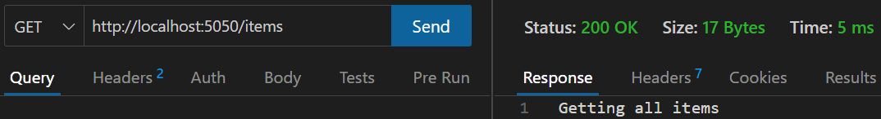

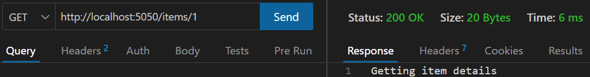

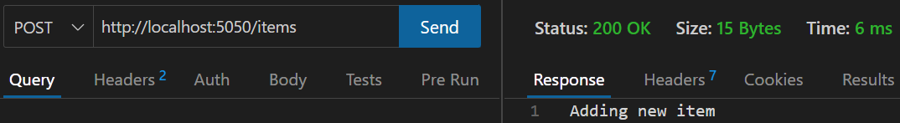

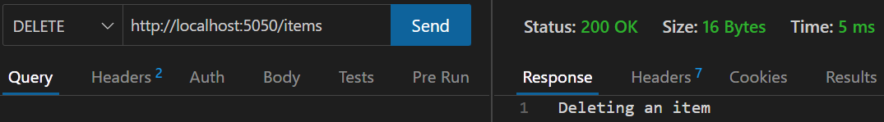

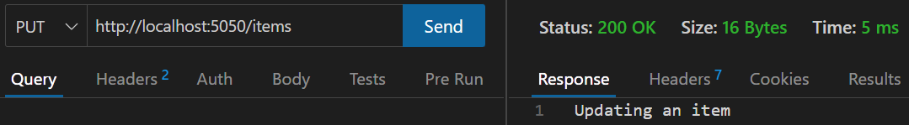

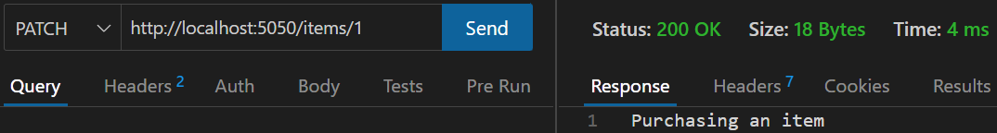

**Config Routes**

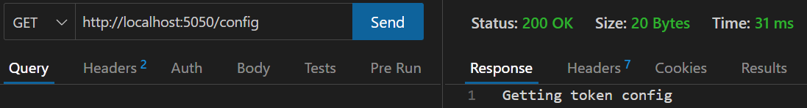

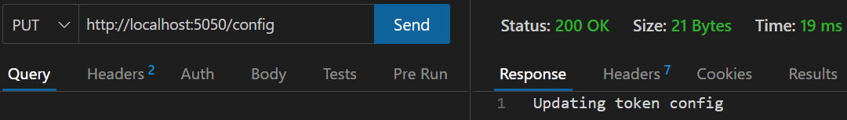

# Evaluation (Milestone 2)

To be completed later.

# Development (Milestone 3)

To be completed later.

# Conclusion

To be completed later.

# References

Ditgital Wings. (n.d.). Retrieved from https://www.digitalwings.nz/

RE:MOBILE. (n.d.). Retrieved from https://remobile.org.nz/

Recycle A Device. (n.d.). Retrieved from https://www.recycleadevice.nz/

TechCharities. (n.d.). Retrieved from https://techcharities.org/

World Computer Exchange. (n.d.). Retrieved from https://worldcomputerexchange.org/